**Note: Some events will require a $2.00 festival button and/or an admission fee**

**For more info on events, phone 425-4852 or contact persons listed for each event**

**Go to** [**www.jrmccsportsrec.ca**](http://www.jrmccsportsrec.ca) **to download poster or check out or join our Facebook**

**events page at: 2023 Lac La Ronge Winter Festival**

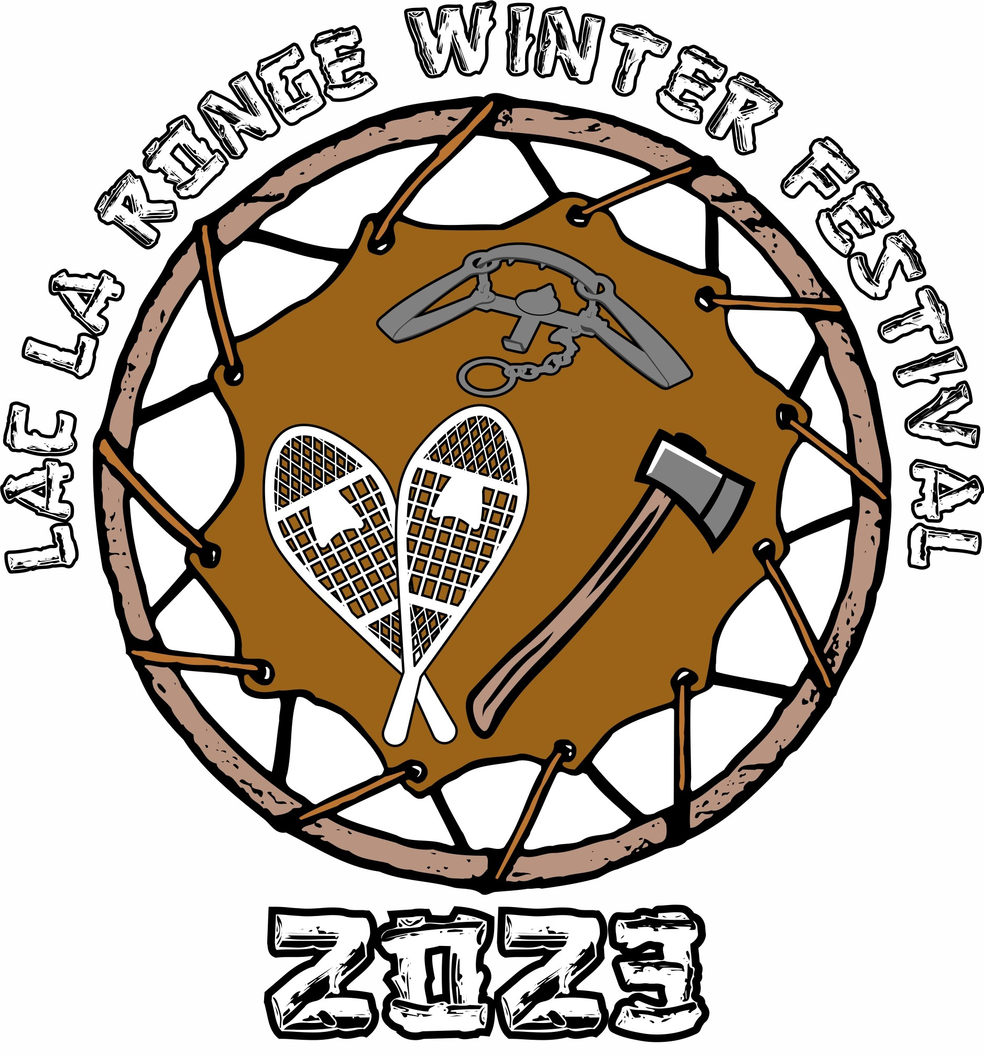

*Calendar of Events: February 24 – March 5*

**2023 LAC LA RONGE**

**WINTER FESTIVAL**

Northern Northern Saskatchewan’s Premiere Winter Event

|  |  |  |
| --- | --- | --- |
| trappers festival.jpg  thumbnail_Image-1.png  **Friday, Feb 24, 2023** | | |
| **Family Fun Night**  JRMCC Hall  Start Time: 6:00 pm  Contact: JRMCC 425-4852  **Festival Queen Crowning**  JRMCC Hall  Start Time: 7:30 pm | | |
| **Saturday, Feb 25, 2023**  **Minor Sports Breakfast Fundraiser**  JRMCC Hall  8:30 am – 10:30 am  Contact: JRMCC 425-4852  **Peter Ross Memorial Cribbage**  **Tournament**  JRMCC Boardroom  Start Time: 2:00 pm  Contact: Kara Schneider-Ross 420-4750  **Northern Talent Showcase**  JRMCC Hall  Show Start Times: 2:00 pm & 7:00 pm  Admission: Festival Button  Contact: JRMCC 425-4852  **Snipers Broomball Tournament**  JRMCC Arena  Start Time 10:00 am  Alicia Sanderson 420-9216 | | |
| **Tracker Tom Charles Memorial**  **Junior Trapper Competition** | |
| La Ronge Urban Reserve  No Entry Fee, Registration 11:00 am | |
| Contact: Jenna Roberts 940-3744 | |
| **Sunday, Feb 26, 2023**  **14th Annual ‘Moochacheech”**  **Memorial Fish Derby**  Bigstone Lake/Youth Haven  Start Time 12:00 pm  Entry Fee: $40.00 Entry Fee  Contact: Sam Roberts 425-9373  **Monday, Feb 27, 2023**  **Elder’s Lunch & Bingo**  Select events will be live on the JRMCC Sports & Recreation Facebook page or the LLRIB YouTube channel  JRMCC Hall  Start Time: 12:00 pm  Contact: JRMCC 425-4852 |
| **Tuesday, Feb 28, 2023**  **Disco on Ice Family Skate Night**  JRMCC Arena  Start Time: 6:00 pm – 8:00 pm  Admission: Festival Button  Contact: JRMCC 425-4852  **Family Movie Night**  JRMCC Hall  Start Time: 8:00 pm – 9:30 pm  Admission: Festival Button  Contact: JRMCC 425-4852  **Wednesday, March 1, 2023**  **Jigging/Square Dancing Competition**  JRMCC Hall  Start Time: 6:30 pm  Admission: Festival Button  Contact: Rita Sewap 425-0199  **Council Cup LLRIB Staff Broomball**  **Challenge**  JRMCC Arena  Start Time: 6:00 pm  Admission: Festival Button  Contact: Nichole Charles 420-9153 |
| **Thursday, March 2, 2023**  **Youth Talent Show**  JRMCC Hall  Start Time: 6:30 pm  Admission: Festival Button  Contact: Fran Ratt 425-9630  **Battle of the Bellies Charity Hockey**  **Game – LLRIB vs PAGC Chiefs**  JRMCC Arena  Start Time: 7:00 pm  Admission: Festival Button  Contact: JRMCC 425-4852  **Friday, March 3, 2023**  **Winter Classic Texas Hold’em**  **Tournament $15,000.00 Cash Payout**  JRMCC Hall  Start Time: 5:30 pm  Contact: JRMCC 425-4852    **11th Annual Jimmy Roberts Memorial**  **Hockey Tournament**  JRMCC Arena  Start Time: 6:00 pm  Admission: $10.00  Contact: Kevin Roberts 420-7529  **Saturday, March 4, 2023**  **La Ronge Ice Wolves**  March 1 vs Melville  March 3 vs Melfort  March 4 vs Flin Flon  All Games 7:30 @ MHU  **Minor Sports Breakfast Fundraiser**  JRMCC Hall  8:30 am – 10:30 am  Contact: JRMCC 425-4852  **11th Annual Jimmy Roberts Memorial**  **Hockey Tournament** (Cont.)  JRMCC Arena & Mel Hegland Uniplex  **10th Annual Chrissy Charles Memorial**  **Volleyball Tournament**  SMVS Gym  Start Time: 9:00 am  Admission: $10.00  Contact: Nichole Charles 420-9153  **Tracker Tom Charles Memorial**  **King & Queen Trapper Competition**  Registration: 10:30 am JRMCC Hall  Start Time: 12:00 pm Urban Reserve  Contact: Norman McKenzie 420-5152  **Fundraiser Cabaret**  JRMCC Hall  Admission $25.00 Advance Tix Only  Start Time: 9:00 pm  Contact: JRMCC 424-4852  **Sunday, March 5, 2023**  **Hockey Tournament** (Cont.)  **Volleyball Tournament** (Cont.)  **King & Queen Trapper Competition** (Cont.)  Start Time: 11:00 am JRMCC Hall  **Community Buckskin Contest**  JRMCC Hall  Start Time: 5:00 pm  Contact: Fran Ratt 425-9630  **Pageant Crowning & Draws**  JRMCC Hall  Start Time: 5:30 pm  Contact: Eileen Roberts 420-1167 | |